Create a ConfigMap from a directory containing multiple files and inject the variables into a pod as environment variables

Creating a configMap from a directory

Directory has multiple files

Injecting them into a pod as environment variables

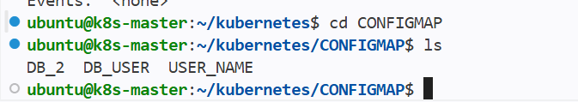

Created 3 files that has varibales

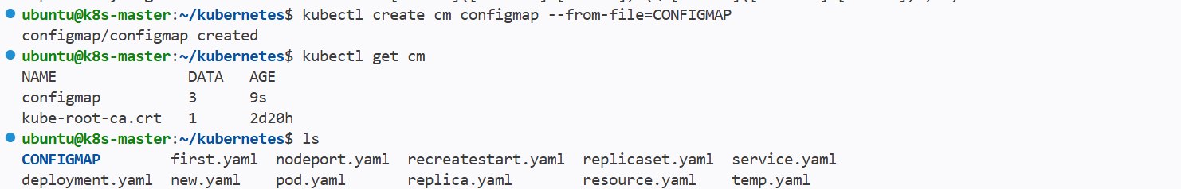

Creating a new configmap using the directory

Synatx:--

Kubectl create cm nameofconfigmap --from-file=<directory name>

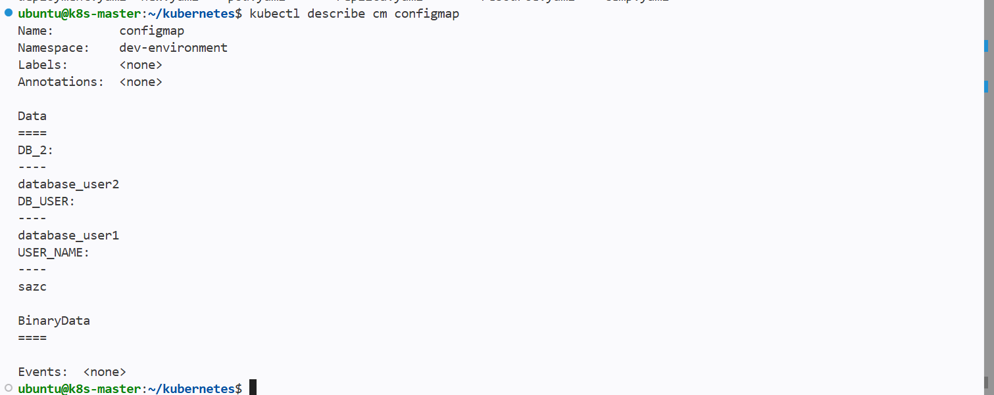

And if we describe the configmap then we can see the files as variables then injecting them into the pod as environment variables

To inject them into pods we have to mention them in the pod yaml file under containers

To inject all variables in configmap to pods use
envFrom:
- configmapRef:
name: nameofconfigmap

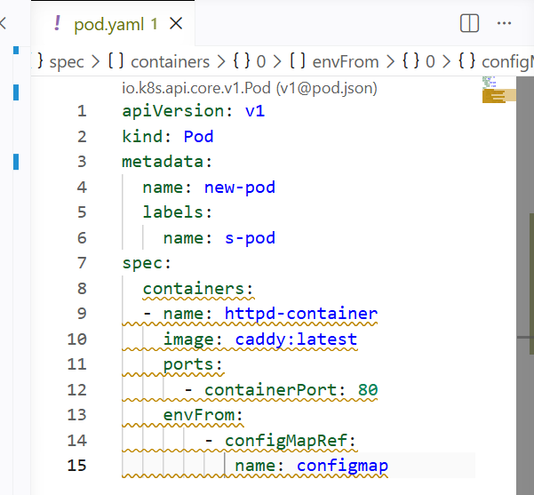

New pod has been created and injected all environment variables

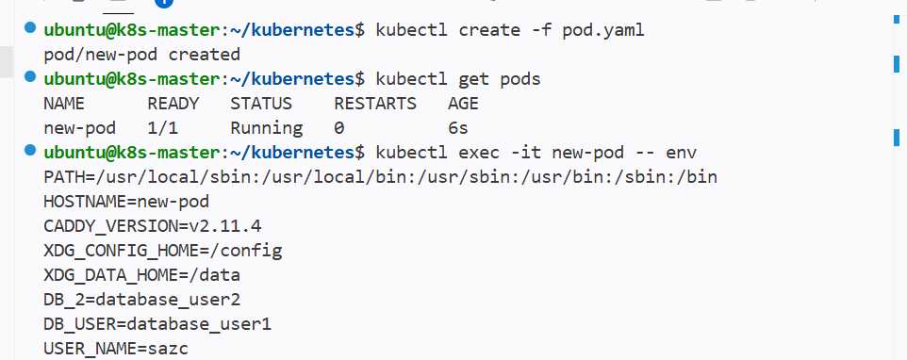

Create a ConfigMap from a file and mount it as a volume inside a pod, ensuring the configuration data is available as files

Giving a file for configmap and

Mounting it as volume inside the pod

The injected varibales should be available as files

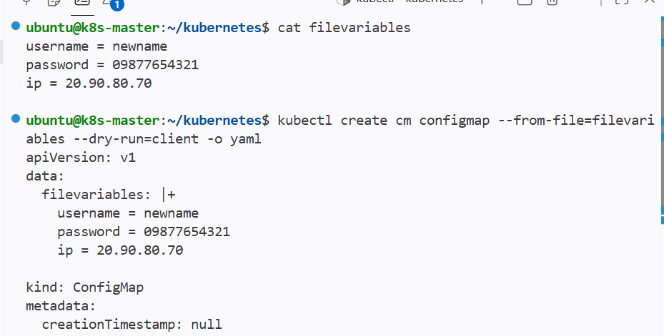

Created a new file named filevariables

Using this file creating a configMap from files

Syntax:--

Kubectl create cm nameofcm --from-file=<filename>

Using the syntax new configmap will be created from the single file that has variables

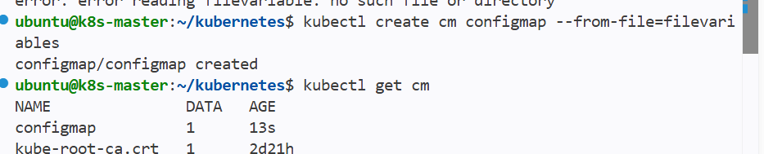

New configmap has been created

Injecting this configmap to the pods using pod yaml file as mount volumes to inject this variables as files instead of direct environmental variables

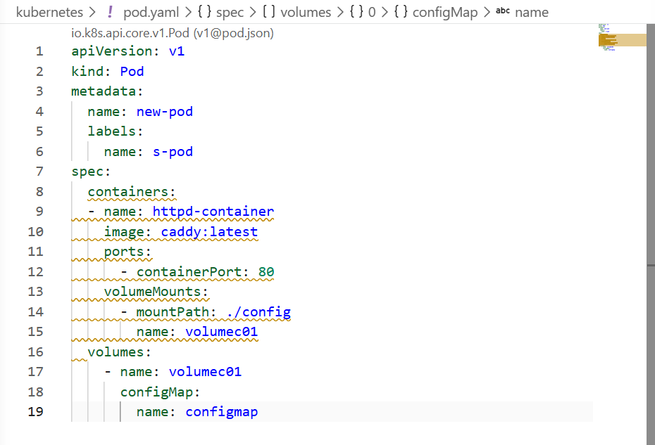
Mounted on new directory and named as config and given the volume name

Created a new volume gave it as configmap

And we can see that new dir config has been created and inside the dir we have our variables file

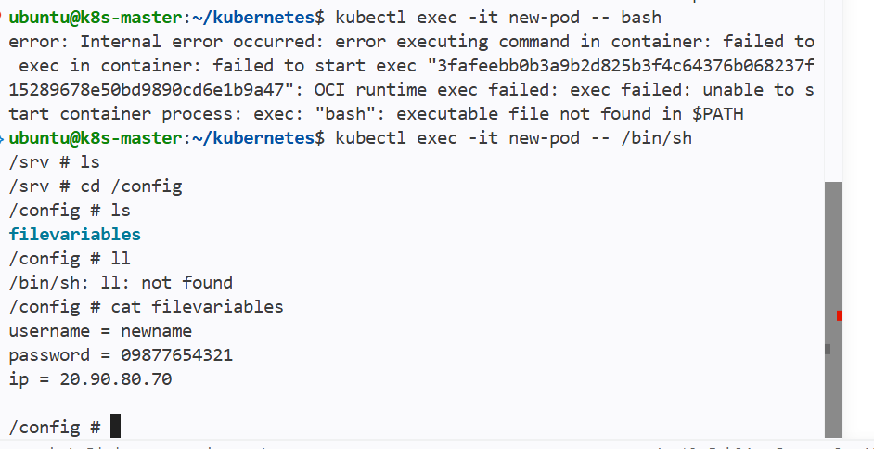

Create a Secret with sensitive information (username and password) and inject it into a pod as environment variables

First we need to convert the sensitive information to base64

And use the encrypt as variables

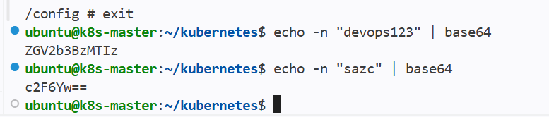

I have encrypted my password and username to base64 and I can use this as my variables

The above file has variables

Creating the secret using file and secret type as generic

Secretname create as secret01

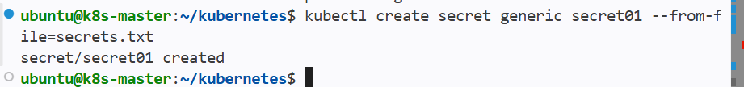

Now giving the secrets to pod using yaml file

And using envfrom to give all variables for pod
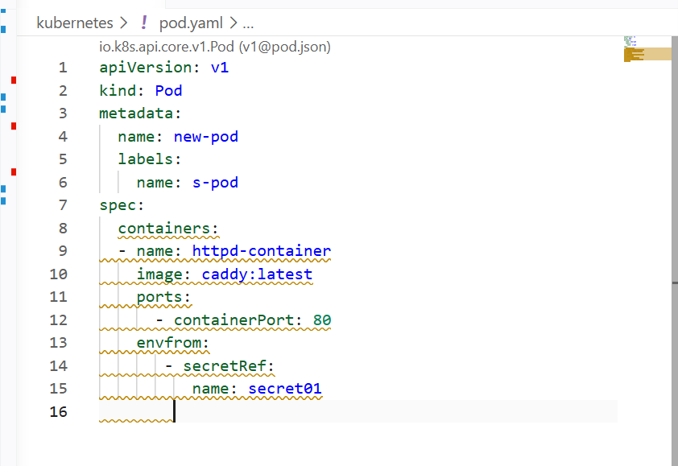

Used envfrom for the entire file that has variabables
If I want to give single or multiple varibales as secrets then I will use env and values of secret and key
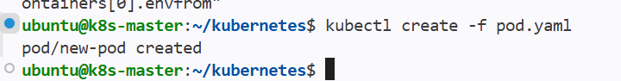

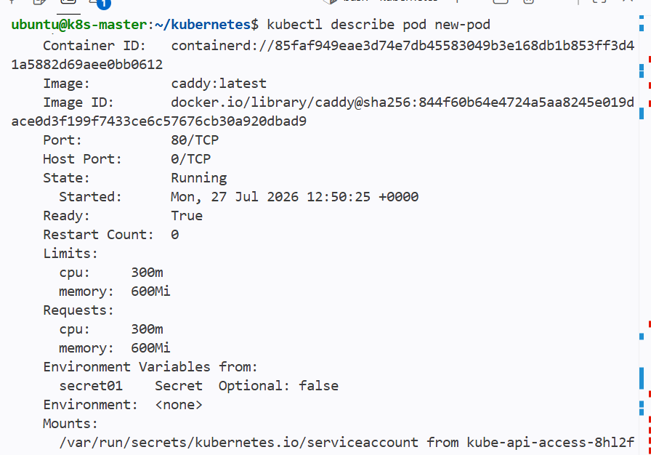

By pod describe we can see that environmental varibales has been added to the po
If I login to the container then do env it should show the varibales

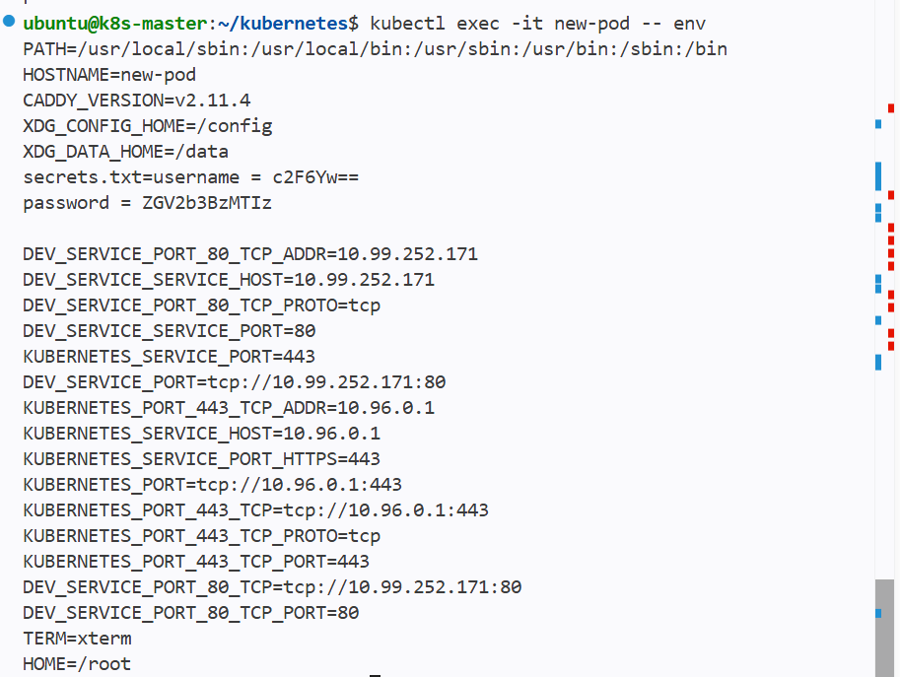

And the username and password can be seen in encrypted format in the environment variables

Create a Secret using a YAML file, mount it as a volume in a pod, and verify the specific Secret values are available as files

Creating the secret using yaml file and mounting it to the pod as volumes

And secrets show be available as files not as env

Dry running the command and getting the yaml file for the secret and using yaml file creating the secret

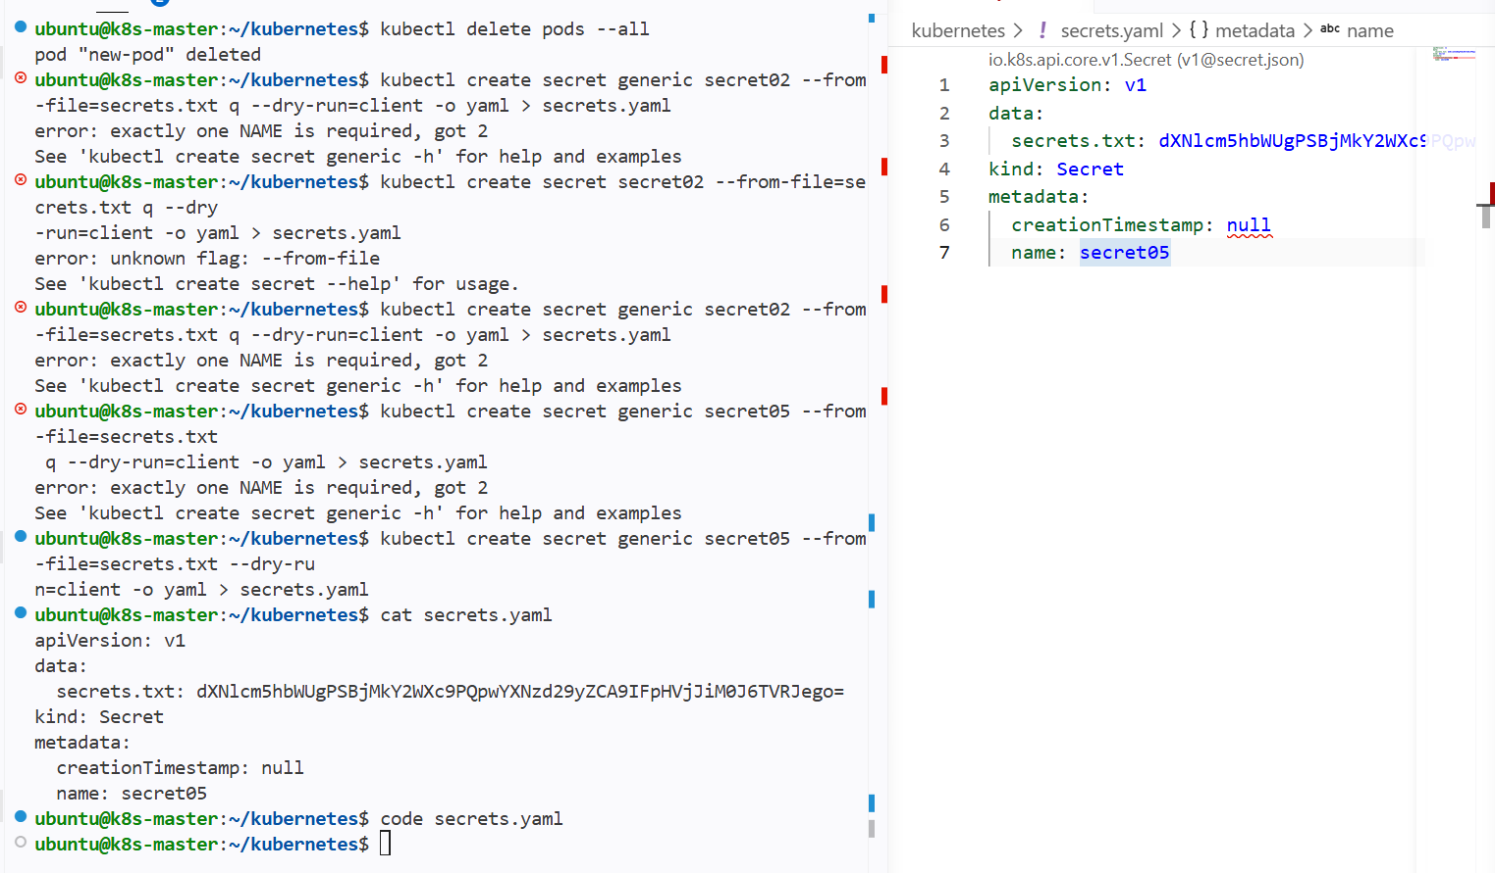

Using yaml file created a new secret and giving it as volume mount fo the pod

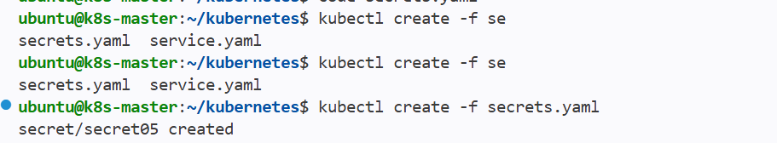

Writing a yaml file for mounting the volume

And giving the secrets file for volume

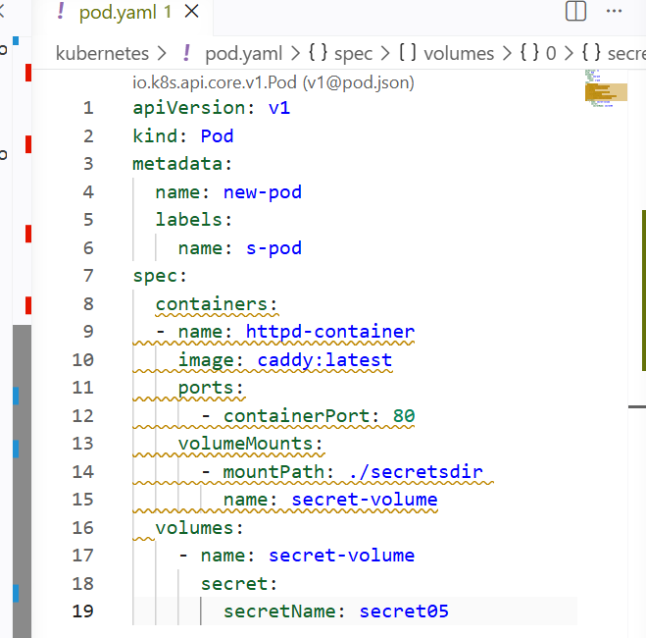

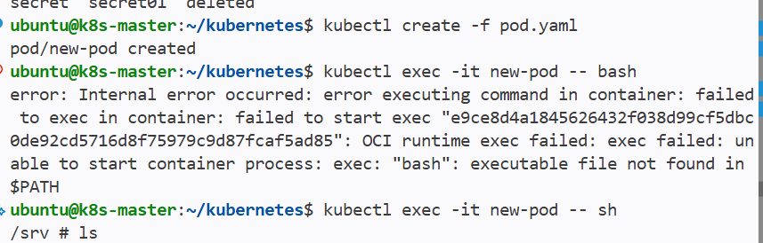
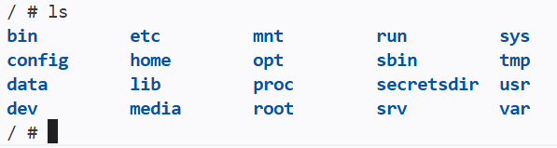

And we can see the dir has been created at root

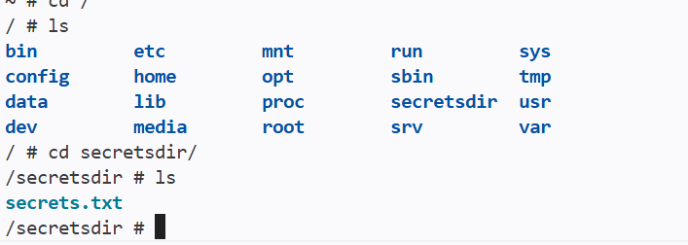

And secretsfile has been mounted to the pod

Inject a ConfigMap as environment variables and a Secret as files into the same pod, ensuring both are accessible within the pod

To do:--

- Inject configmap as environment variables
- Inject secrets as file to the same pod

First creating a config map that has variables

Below file will be inject as configmap to the pod as varibales
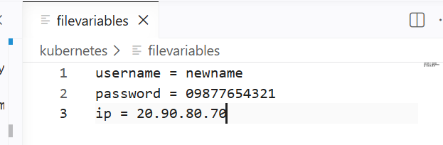

Below file will be inject as secret as file to the pod

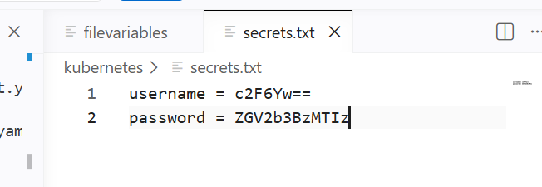

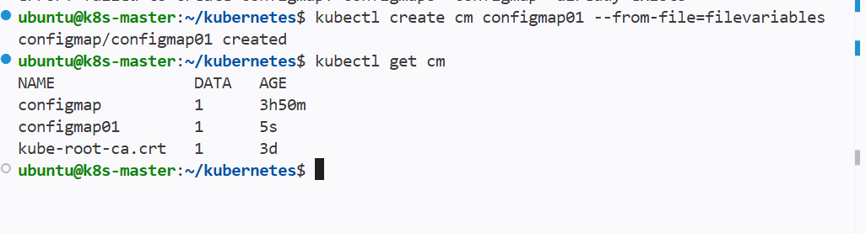

Created configmap using the file and passing as env variables to the pod

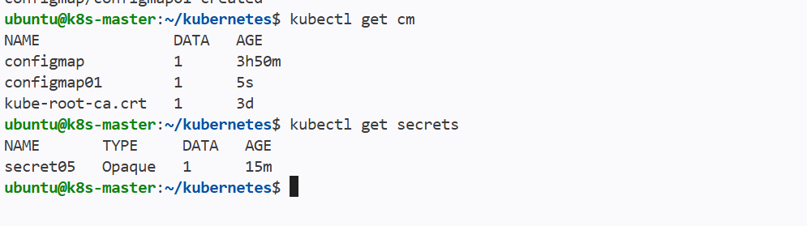
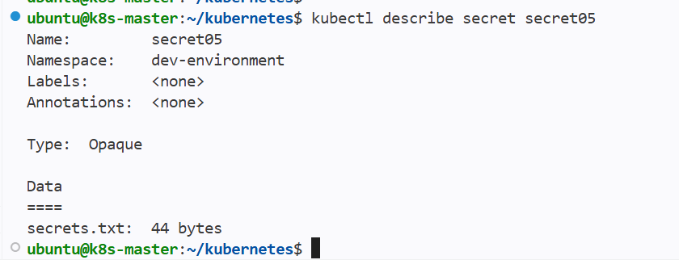
Created secret using a file and passing as file and mounting the volume to the pod

Creating a new yaml file for pod and giving both configmap and secret
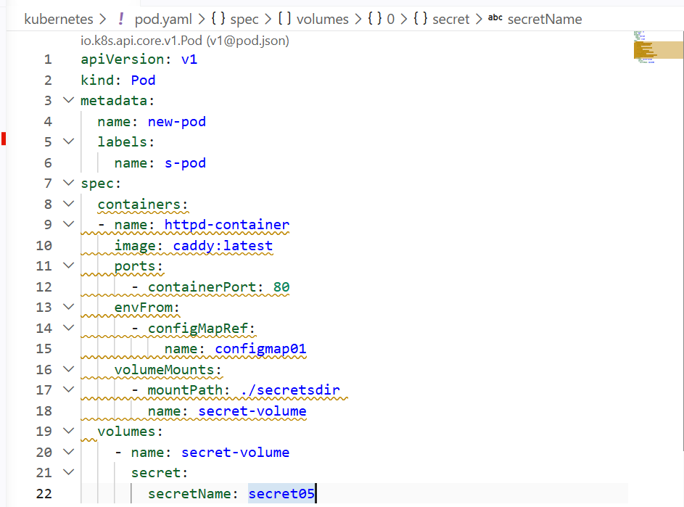

Configmap is configured as env varibales for pod
Secret is configured as file for the pod

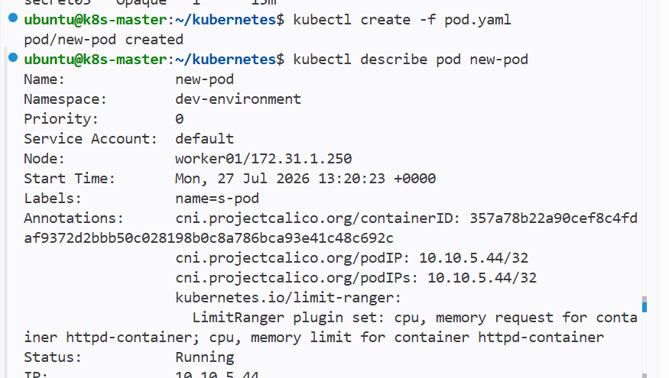

New pod has been created and if I check the secret I need to see it only in bites and not the actual values

Login to the container and check for files and environment varibales that passed to the pod

In env of pod we can see the variables

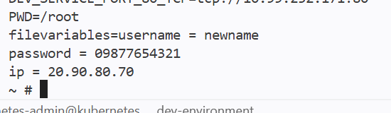

And secrets file has been generated in the pod



